Experiment 5
System Information Commands
Aim
To execute uptime, date, and mv commands.
Procedure
1. Check system uptime.
2. Display current date.
3. Rename a file using mv.

Output
uptime Command
Shows system running time.

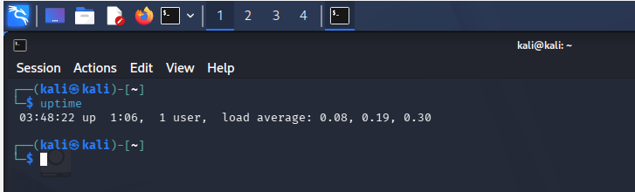

date Command
Displays current date and time.

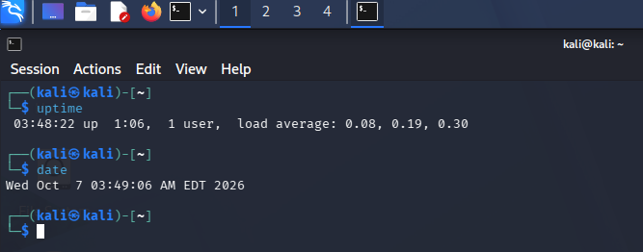

mv Command
Moves or renames files.

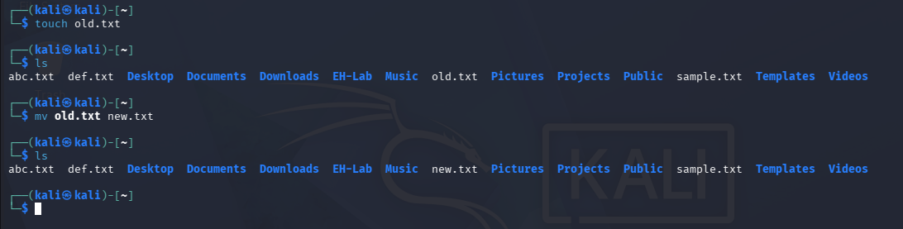
Result
Successfully executed uptime, date, and mv commands.

